2.5 RELEASE NOTES

Hilti ON!Track
Release date: 04.03.2017

1 Release Highlights 2
2 New Features 2
2.1.1 New languages 2
2.1.2 Confirm delivery 2
2.1.3 Location management 9
2.1.4 Terminal location 12
2.1.5 Hilti asset status information 15
2.1.6 Asset usage information available 16
3 Enhancements 17
3.1.1 Customized Hilti asset templates 17
3.1.2 Grid functionality for more than 5000 assets 18
3.1.3 Newly organized asset details panel 18
3.1.4 Hilti unique customer number 19
3.1.5 Additional characters for user names and user roles 20
3.1.6 Creating a username 20
3.1.7 Performance improvements 20
3.1.8 Information on completed asset services 20
3.1.9 Product documentation can be accessed via the mobile app 21
3.2 Bug Fixes 22
3.2.1 Loading time of the asset templates page 22
3.2.2 Editing consumable asset details 22
3.2.3 Synchronized assets among locations and devices 23
3.3 Troubleshooting 23

Release Highlights
The 2.5 release provides the option with the confirm delivery feature for companies to operate a more robust and secure chain of ownership when tracking and moving assets. Likewise, significant enhancements have been made in the area of location management, which streamlines the movement of assets across location types. Additional visibility on the mobile app in regards to services, and viewable attachments for assets was also achieved. With the newly introduced Hilti asset status for Hilti tools, an easy check can be done on the Hilti reported status (e.g. stolen) and collected/returned Hilti tools can be quickly retired. Hilti asset templates can also now be customized with a description, cost code and picture. In addition, global searches for large customers was optimized and other bug fixes across both the web and mobile app were solved. Finally, three new languages including Czech, Slovak, and Turkish are now supported. The rest of this document will provide a more in-depth overview of what is included within the 2.5 software release.

New Features

New languages
Czech, Slovakian, and Turkish are now available in the ON!Track mobile and web application.

Confirm delivery
Confirming deliveries of assets is much easier and provides the possibility for a much more secure chain of custody to have transparency over the movement and ownership of assets.

Turning on the confirm delivery feature
If the added functionality of confirming deliveries within the ON!Track application is relevant for your company, it can be turned on in the ON!Track web application under the company settings, transfer settings,
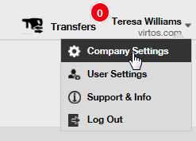
and set the required delivery confirmation to yes, and save:
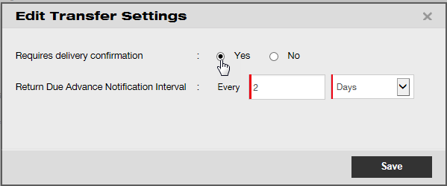

Confirm delivery turned off
If a company does not require the confirmation of all types of assets which are transferred, then the confirm delivery setting can be kept off. Although confirm delivery is switched off it is still now possible to require some assets to be signed for in confirmation of their being transferred.

Face-to-face transfers
For face-to-face transfers the warehouse manager or jobsite manager should prepare the transfer on the mobile app. Once all the desired assets have been scanned or entered in the transfer, scroll all the way down to the bottom of the transfer details, click on the confirm delivery card, and hand the phone over to the responsible employee to sign in confirmation.
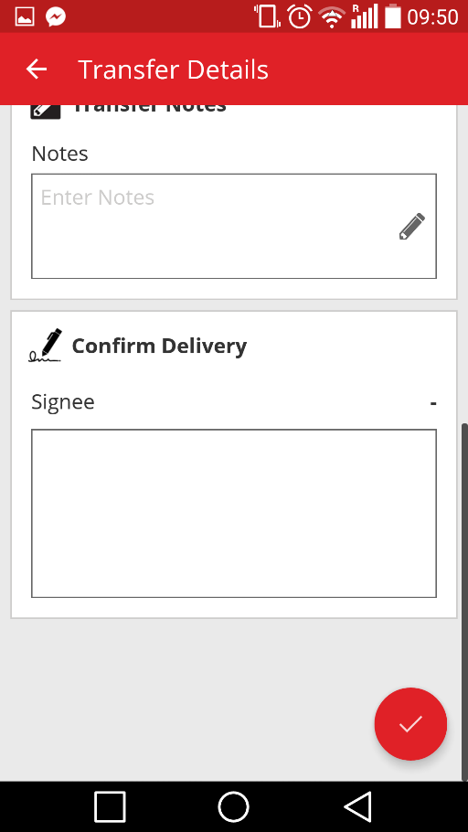
To sign, tap inside the signature field and enter the signature. Signatures can also be entered with a high-precision capacitive pens in order to make it easier for signing the full name on the mobile device.
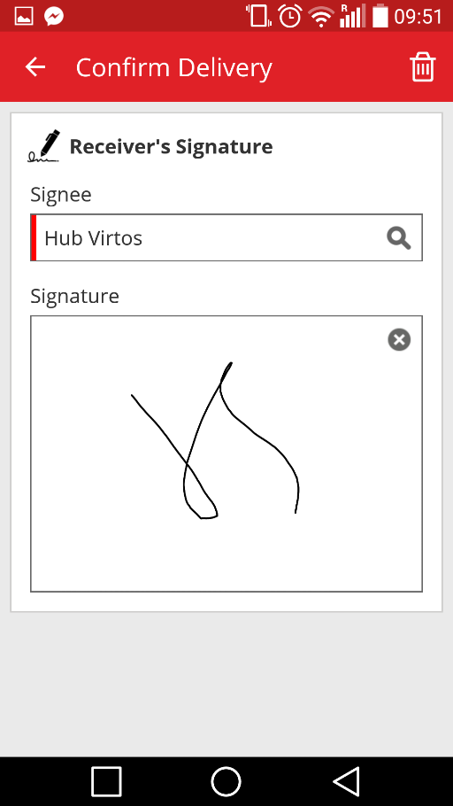
Signing the card with the confirm delivery feature switched on results in an auto confirmation of the delivery. This signature and the time stamp of when it was confirmed will be saved with the transfer history. Under the asset information, “confirmed by” and “confirmed date” will be shown in the transfer reports and in the asset details side panel as shown below.
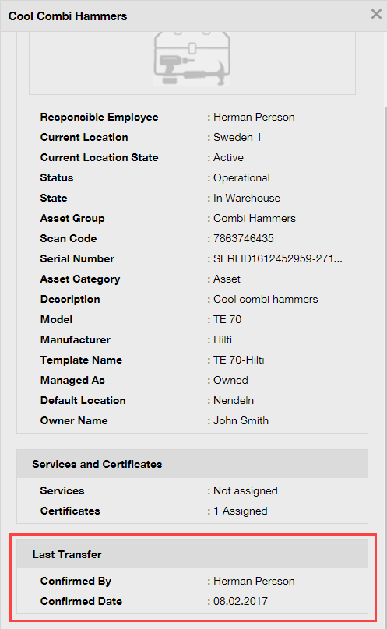

When transfers are not face-to-face
When transfers are not face-to-face (and for example are given to a driver to be delivered), use the confirm delivery feature to request confirmation that the transfer was delivered. The warehouse manager can complete a transfer as usual on the web app or on the mobile app. To confirm the delivery, the location manager or responsible employee should go into confirm delivery on the mobile app where all the assets the user is able to confirm are automatically synchronized in that list if the user is online.
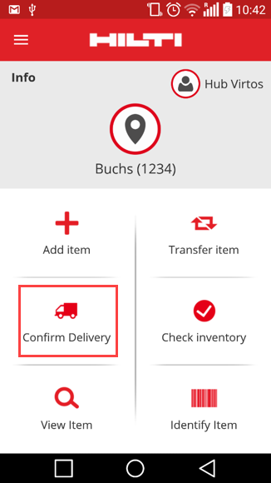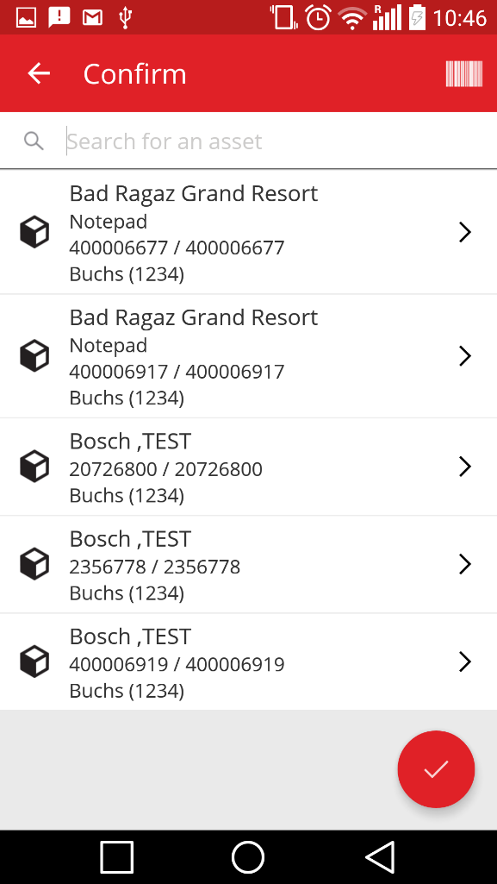
The user should scan or tap on each asset to confirm. If a specific asset in the confirm delivery list has not been received, do not click on it, leave it there and call the warehouse manager to inform him/her that it did not arrive and they should edit the transfer.

*Note: Admins will not see the entire list of assets they can confirm because the list of all system deliveries would be too extensive.

Who can confirm deliveries?
Admins can always confirm any delivery in the system. Location managers are able to confirm any delivery made to the location(s) where they are the location manager. Responsible employees can confirm a delivery of assets for which they are responsible. Additionally, any user can be granted the permission of “confirm any delivery” (this is a separate permission from the permission to perform any transfer) if desired.
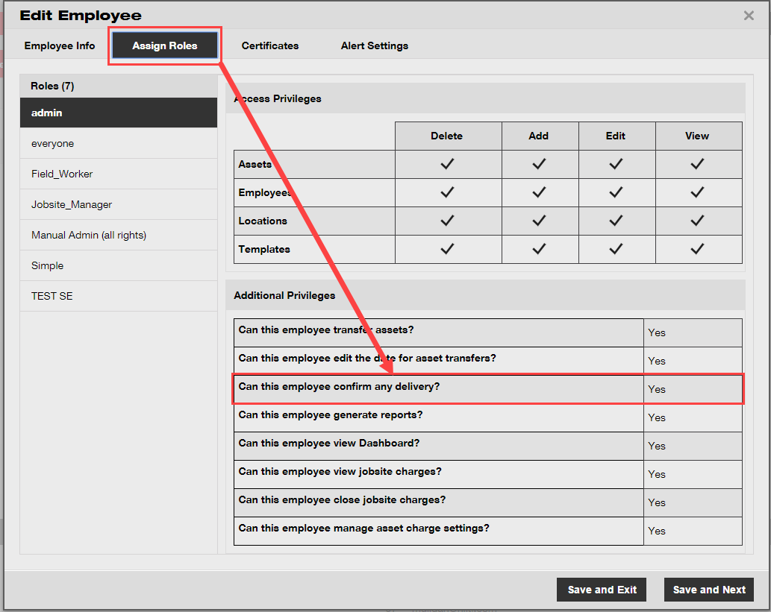
*Note: be very careful with assigning the permission of “confirm any delivery” to a user. This permission should only be given to people such as warehouse employees who can be trusted with this “admin” type of permission.

Auto confirmation of deliveries
When a warehouse manager is returning tools to his own warehouse, or in the case of a jobsite manager transferring assets back to their own jobsite (where they are the manager of the location), the assets are auto confirmed upon being transferred.

When several people work at the same warehouse, only one person is defined as “location manager”. The additional employees can be assigned the right to "confirm any delivery" and set their "current location" to the warehouse location and then any transfer they perform back to their location will be auto confirmed.

Confirmed deliveries viewable in transfer reports
As an extension of the current transfer reports section, it is now possible to view by whom an asset was confirmed by and on which date it was confirmed, which provides better transparency. When selecting the fields to show in the report be sure to select “confirmed by” and “confirmed date”.
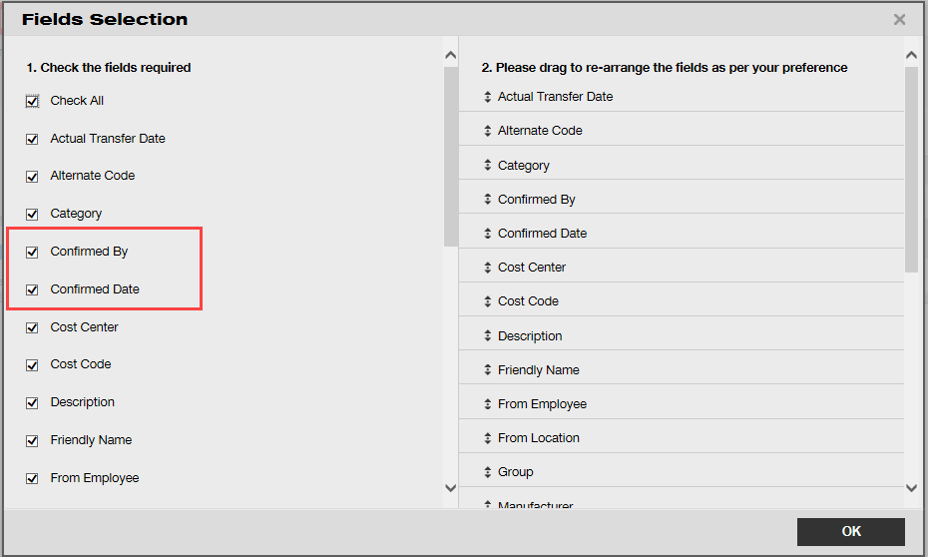

Location management
With the new location management concept of “location states”, it is now more efficient to manage locations when it comes to the end of the life of the location (i.e. a jobsite which is complete).

There concept of a location state enables the location to be classified as either active, inactive, or archived. This state of the location should be set when adding a new location or can also be changed or added under editing a location under the location details. The default state of a location is set as active.
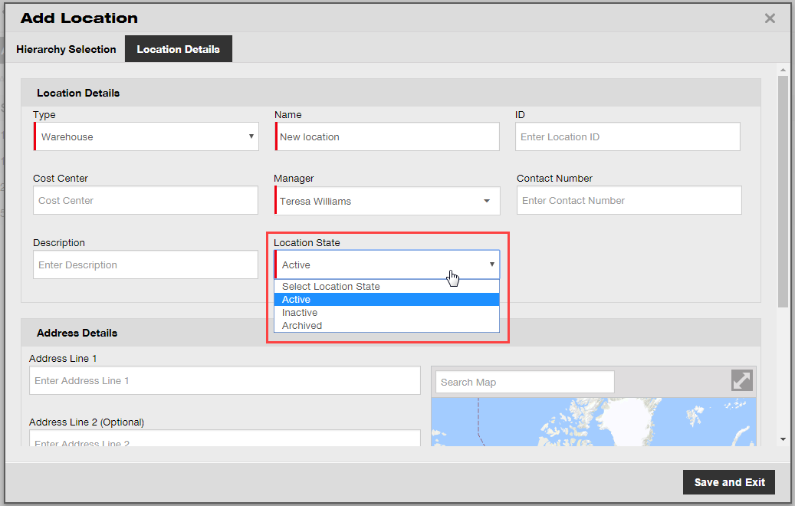

What does active, inactive, and archived location state mean?
Locations which are in the “active” state are locations which are being used by a company and its employees (i.e. warehouse, vehicles in use, ongoing jobsites, etc). Active locations are visible for all users to be able to transfer assets, commodities, and consumables to/from such locations.

The location state “inactive” can be used when a project is finished at a certain location and no more assets should be transferred there. Inactive locations will be visible for all users but they will be unable to transfer assets to such locations, it is only possible to transfer assets out of an inactive location.

To make it easier for users to identify if the location state is active or inactive at a glance, there is a small “x” next to the location icon to display it as inactive. Similarly, the icons shown on the web are refelcted on the mobile app.
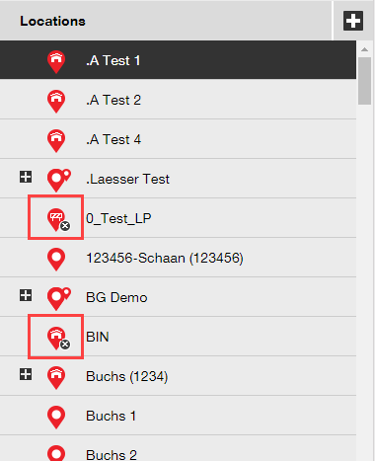

Setting a location as “archived” is similar to a soft delete and such locations are then only visible to admins via the company settings page. No assets can be transferred to or from an archived location and before a location is archived all the assets and commodities must be transferred out of the location – consumables can be kept on archived locations. Additionally, if there are assets that have a location as their default, you will not be able to archive it. To reinstate archived locations, the company admin can go to the archived locations list under company settings and select the desired location(s), and then mark them as active, or inactive – this will make them visible again for all company employees.
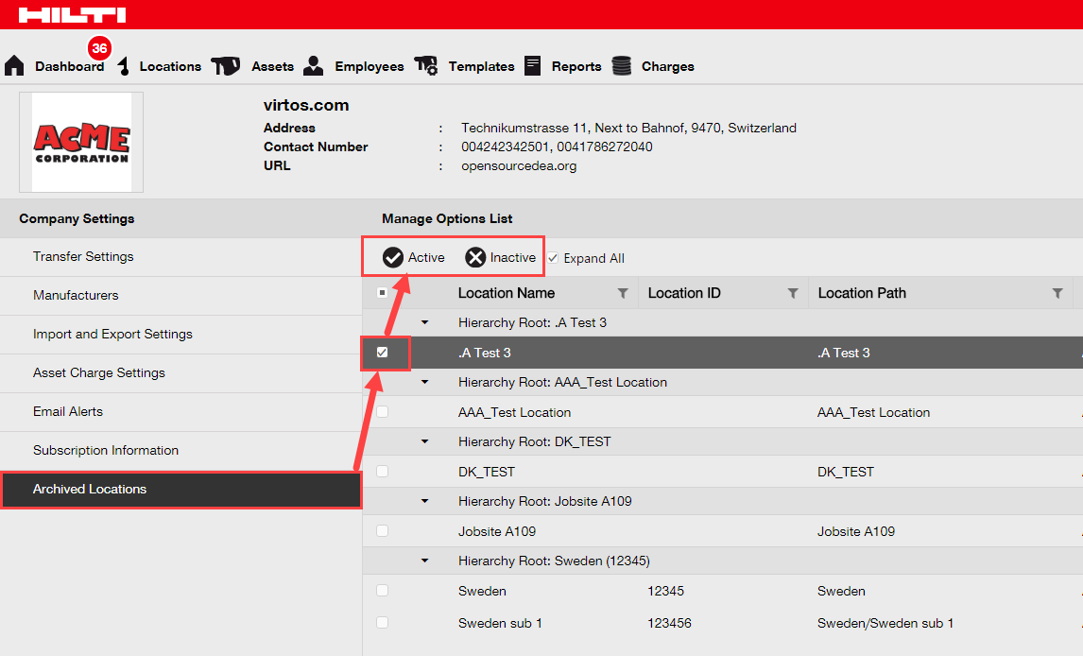

Terminal location
There is a new location type available called terminal location.
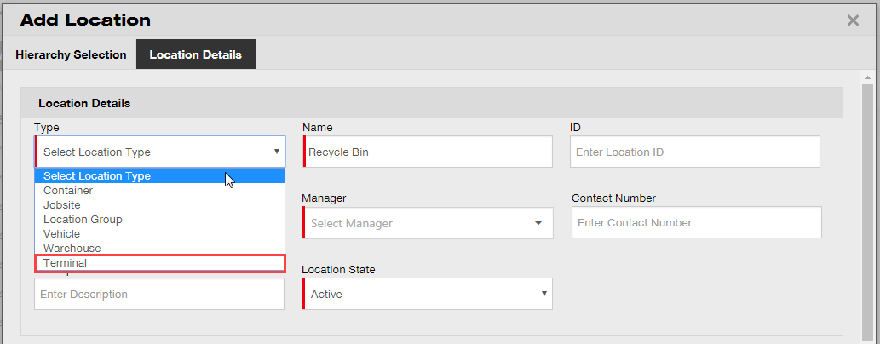
When creating a terminal location, a new field will appear where you can select what the status of an asset should be after it is transferred to this new terminal location. Terminal locations can be itentified by the under construction icon.
On the mobile app the icon is also shown as an under construction icon in order to identify the terminal location type.
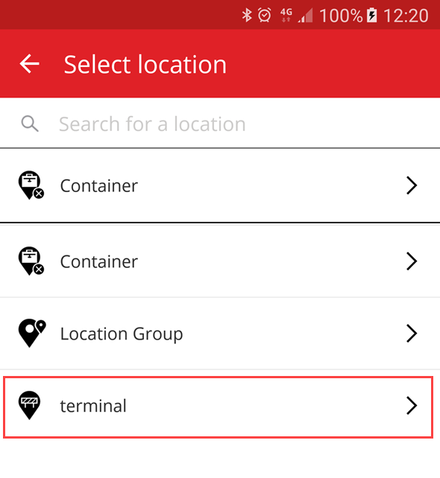
Assets transferred to this location will automatically be switched to the defined asset status for the terminal location and will recive the asset state of “unavailable”. If a terminal location is set up with no status, then assets will keep the stuts they had before the transfer. If assets were never assigned an asset status, then they will remain without a status, even when transferred to a terminal location. 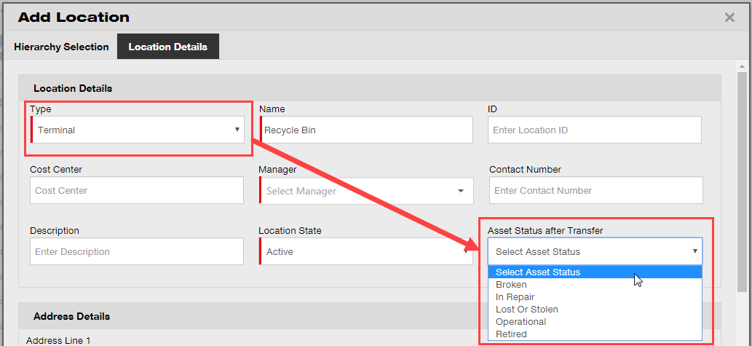
If a terminal location is set up with the “asset status after transfer” to retired, the list of assets will not show by default and the filter will need to be removed to view the list of assets at this particular terminal location.

*Note: The default filter in asset view hides the retired assets and therefore to show retired assets select this field in the asset status column. 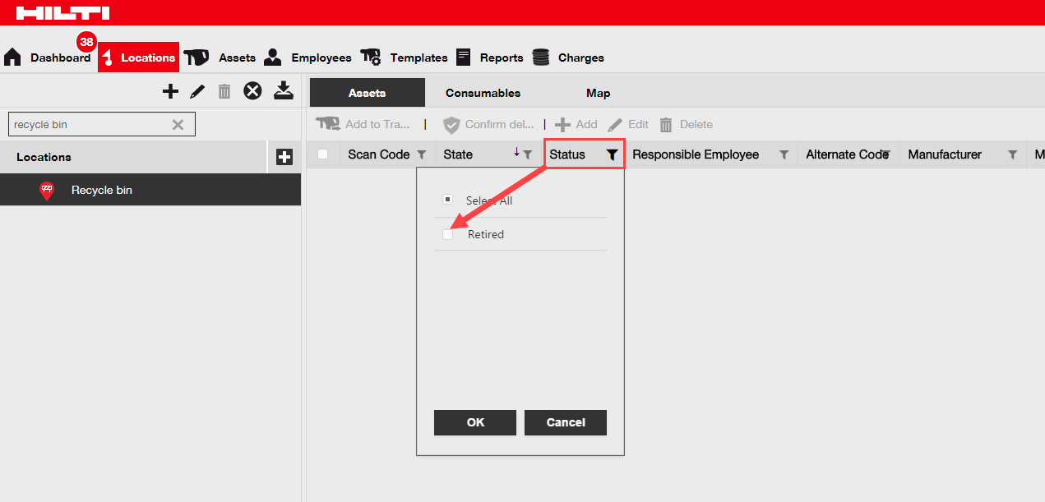
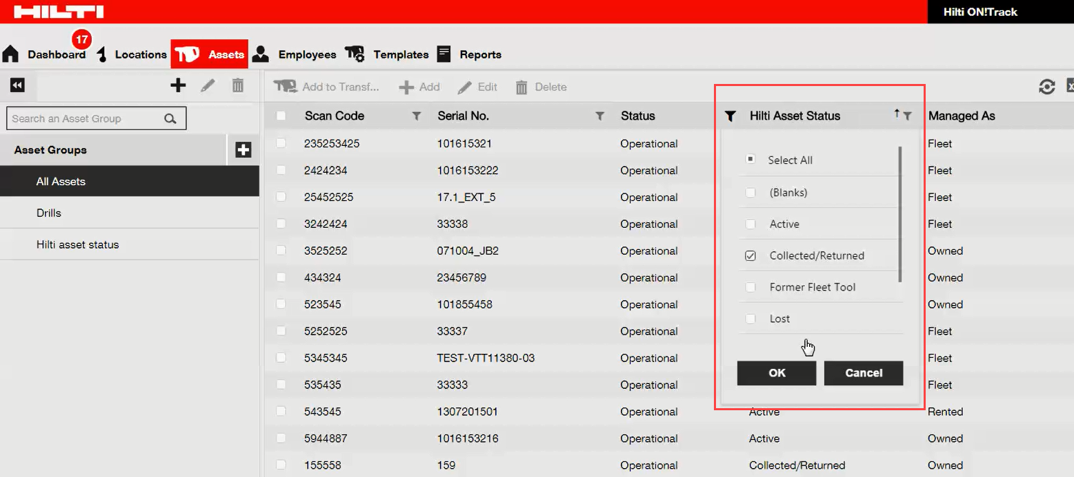
With the new Hilti Asset Status field shown and in combination with the new terminal location type it is now possible to mass retire all the collected/returned Hilti assets. After the creation of the terminal location or unless there is already one created, filter down to the Hilti Asset Status of collected/returned assets.

Select all Hilti collected/reutrned assets and then transfer them to the terminal location with the default asset status of retired.
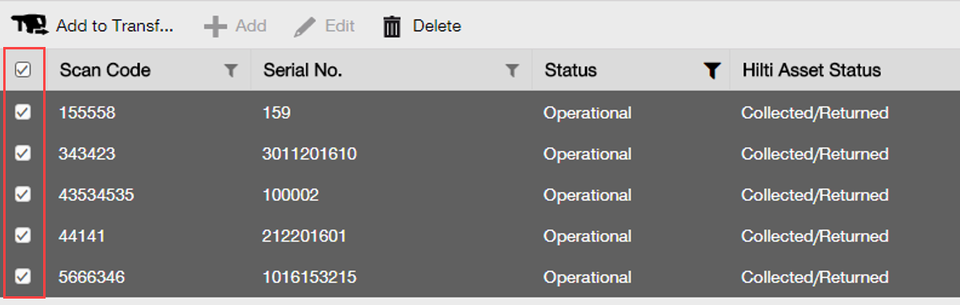
Make sure to create a terminal location with the “asset status after transfer” to “retired”.
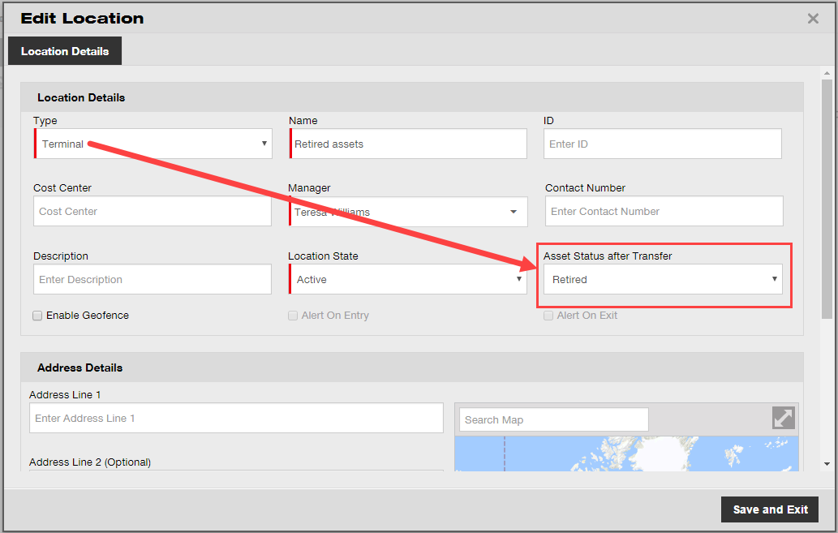

Hilti asset status information
The newly introduced Hilti asset status field (seen in the grid column below) provides the respective status of a tool as reported in the Hilti systems.
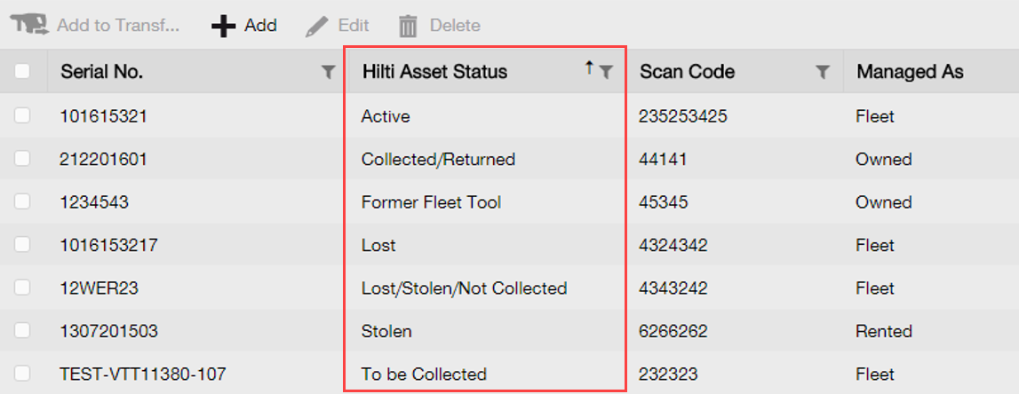

This new Hilti asset status information provides the possibility to cross check if a stolen Hilti asset was already reported as stolen to Hilti. It also provides information when a fleet collection/exchange is due or when tools have been collected/returned to Hilti.

The Hilti asset status can be viewed in many different areas on the web interface such as a column available in the grid column chooser as shown above, the report selection, the asset details side panel (shown below),
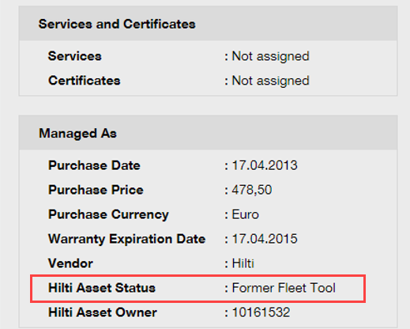
and under the managed as tab when editing an asset (shown below). 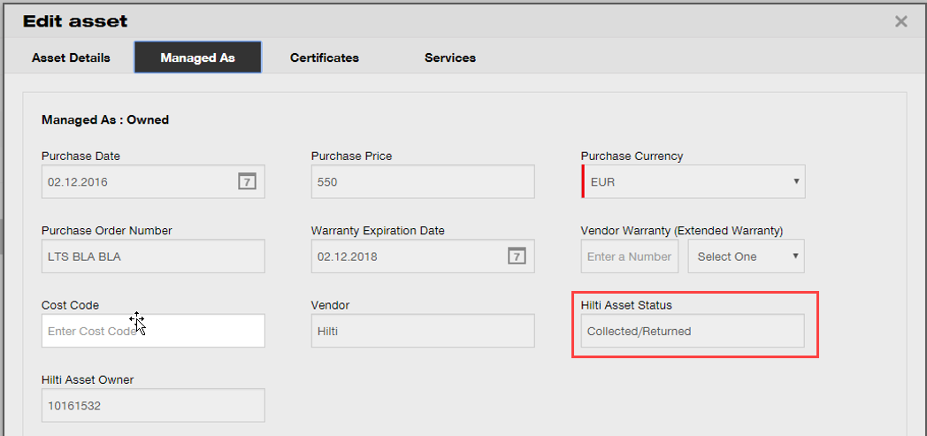
*Note: The Hilti asset status is currently not viewable on the mobile app.

Asset usage information available
It is now possible to have a quick glance on the current asset usage relevant for determining the relevant service subscription bucket. The “total registered items” are a sum of the number of unique assets (excluding retired), commodities per scan code and consumables per scan code. This is visible under the company settings and subscription information.

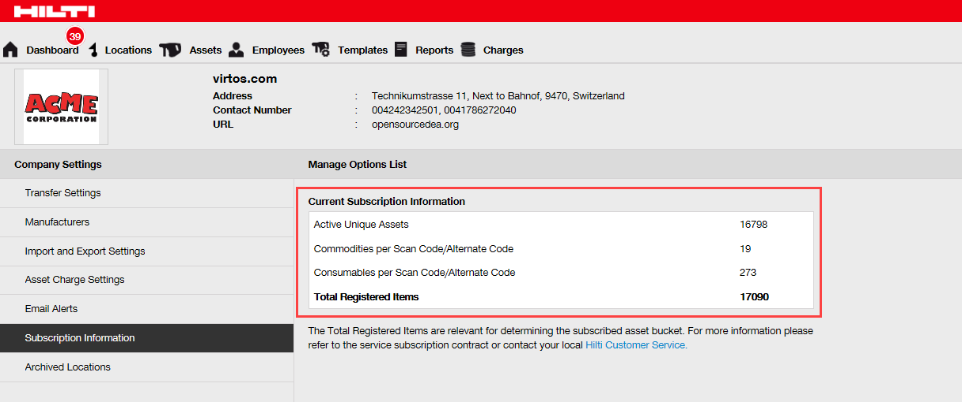

Enhancements

Customized Hilti asset templates
It is now possible to enter customized information in Hilti asset templates for the description, cost code, and picture fields. The customized Hilti asset template information is shown for all linked assets.
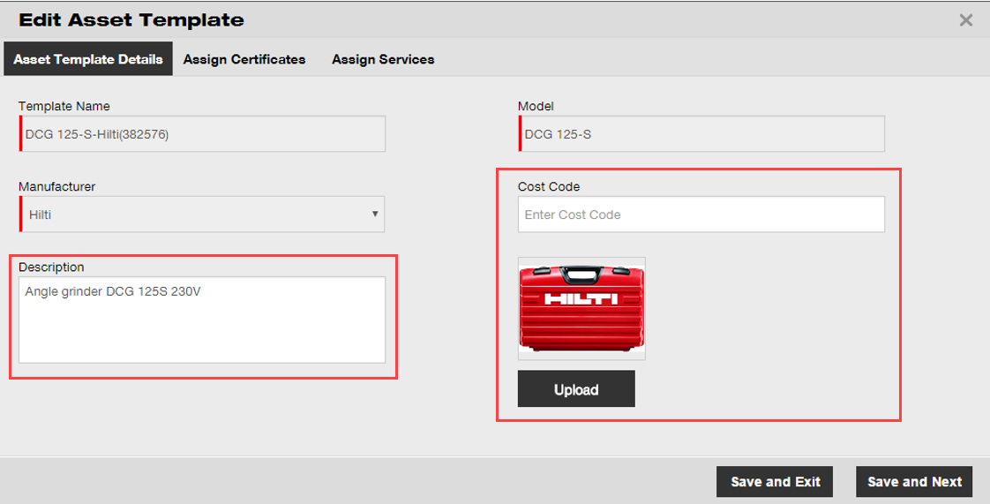
*Note: Once customized information is added in the open fields, the original Hilti data from the template cannot be retrieved any longer.

Grid functionality for more than 5000 assets
For large customers with more than 5000 assets, the search should be first narrowed down by searching among scan code, alternate code, friendly name, model, manufacturer, description, serial no., notes, default locations, and default employee. 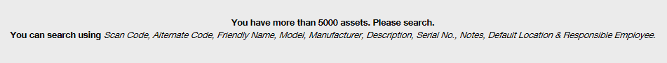
Additionally, the grid results for more than 5000 assets can now be exported via excel.

*Note: Previously when searching across 5000 or more assets and locations the grid would become paginated and it was not possible to filter results. This is no longer the case with this new improvement for large customers searching across many assets.

Newly organized asset details panel
The asset details panel has been restructured to create more order by grouping similar types of details together. The new asset panel boxes can be expanded and collapsed by clicking on the box headers.
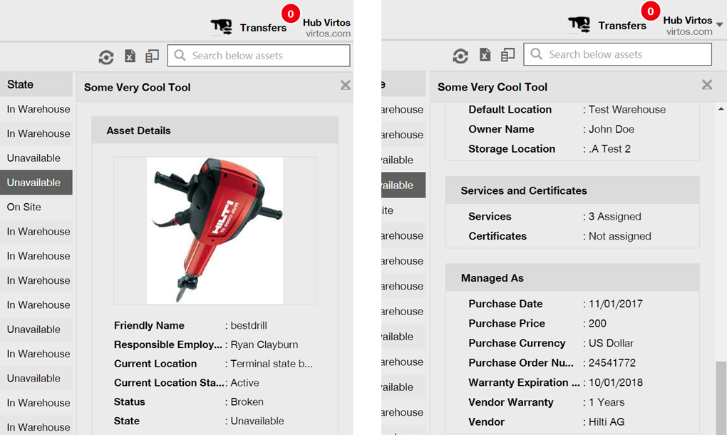

Hilti unique customer number
The Hilti customer number (SAP customer number) can now be viewed under company settings.
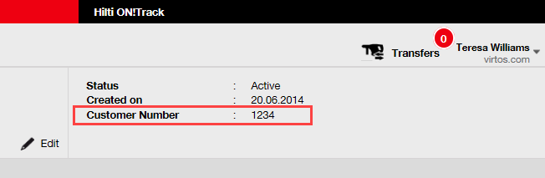

Additional characters for user names and user roles
Special characters are now accepted when defining the name of customer user roles and asset groups.

Creating a username
The amount of characters required when creating a username is now 2 instead of 3.

Performance improvements
Many improvements were made to the search functionality and to various views in the application.

Information on completed asset services
It is now possible to access completed service information on the mobile app via the asset details. The most recent completed service will be displayed in the completed service field. By selecting the completed service field, the user can see more details on the: service name, service description if any, cost, service vendor, date of last check, service interval, date of next check, notes, and any attachments.
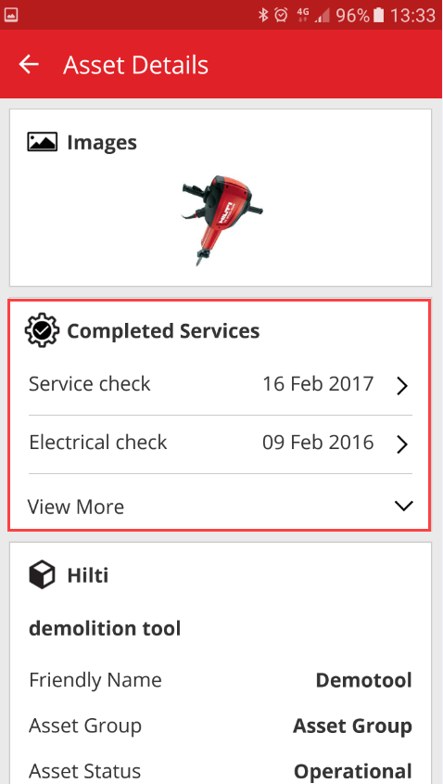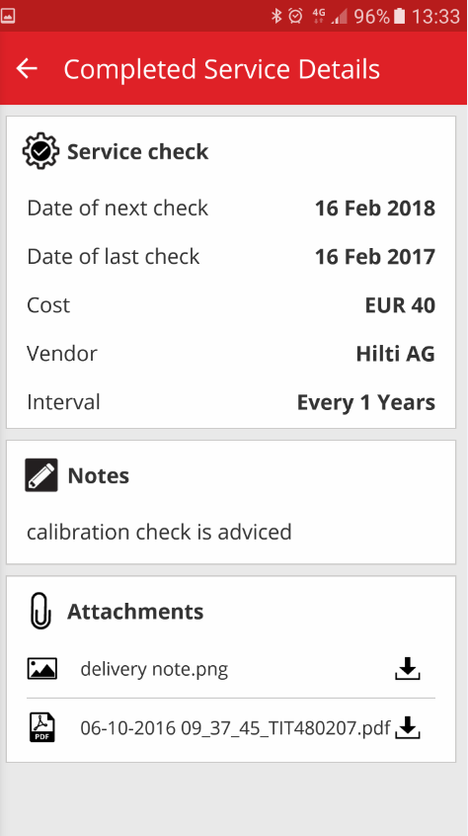

The following types of attachments are supported: jpeg, jpg, png, pdf*, docx/doc*, xls/xlsx, txt*
*Note: these attachment types are subject to 3rd party app availability on the mobile device.

Product documentation can be accessed via the mobile app
Release information and product documentation can now be accessed directly via the mobile app. Under the ON!Track settings, find the app info and click on help to link to the latest product and release information page on Hilti Online.
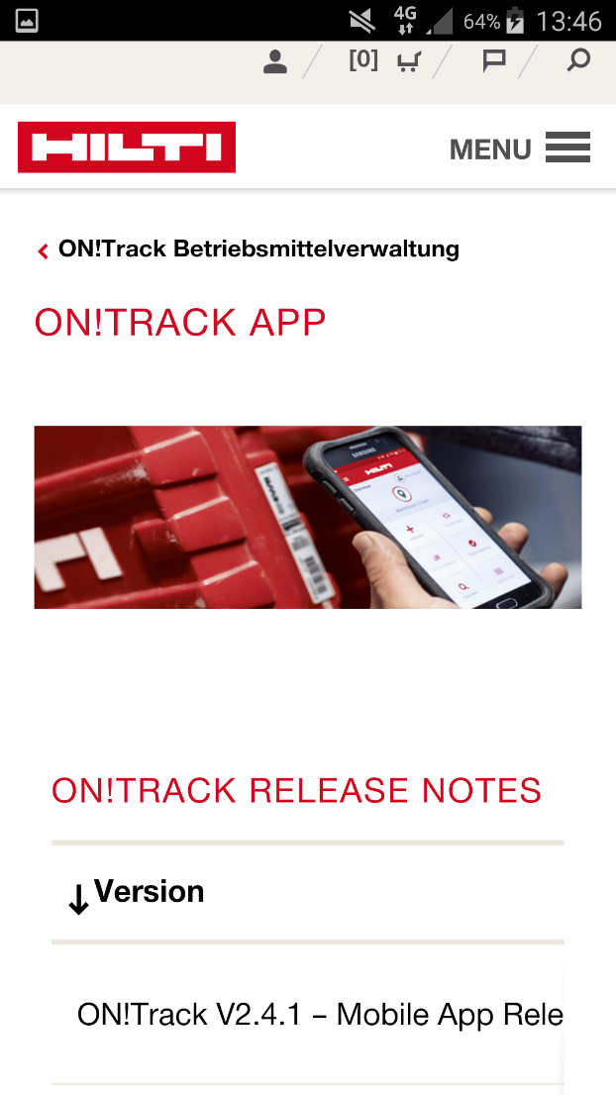
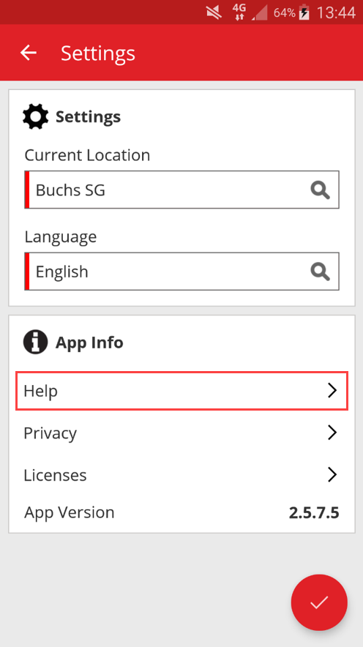

Bug Fixes

Loading time of the asset templates page
The performance of the loading time for the asset templates page has now been improved significantly.

Editing consumable asset details
Previously it was not possible to edit some fields for a consumable asset when there was no manufacturer selected. Now the fields are no longer locked and can be edited in the asset details even when there is no manufacturer selected for a consumable at the time it was added.

Synchronized assets among locations and devices
The inconsistency of the number of assets showing on different devices under search by location is now fixed with regular synchronizations performing and the ability to perform a synchronization on demand.

Troubleshooting
If any issues should be experienced after the release, please clear the browser cache and refresh the ON!Track page. If the problem still persists please reach out to Hilti Customer Service

